Project Design Phase 2 :

Data Flow Diagrams and User Stories

|  |  |
| --- | --- |
| Team ID | IBM-Project-29170-1660121813 |
| Project Name | Emerging Methods for Early Detection of Forest Fires |

# Data Flow Diagrams:

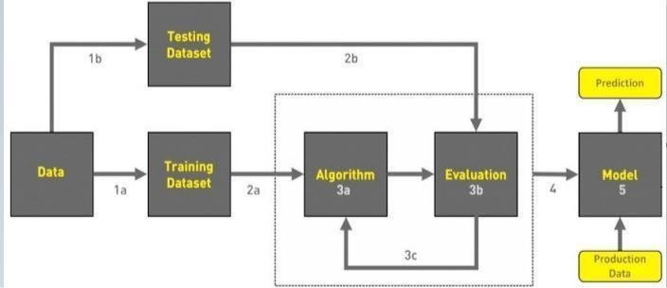

1. COLLECT DATA

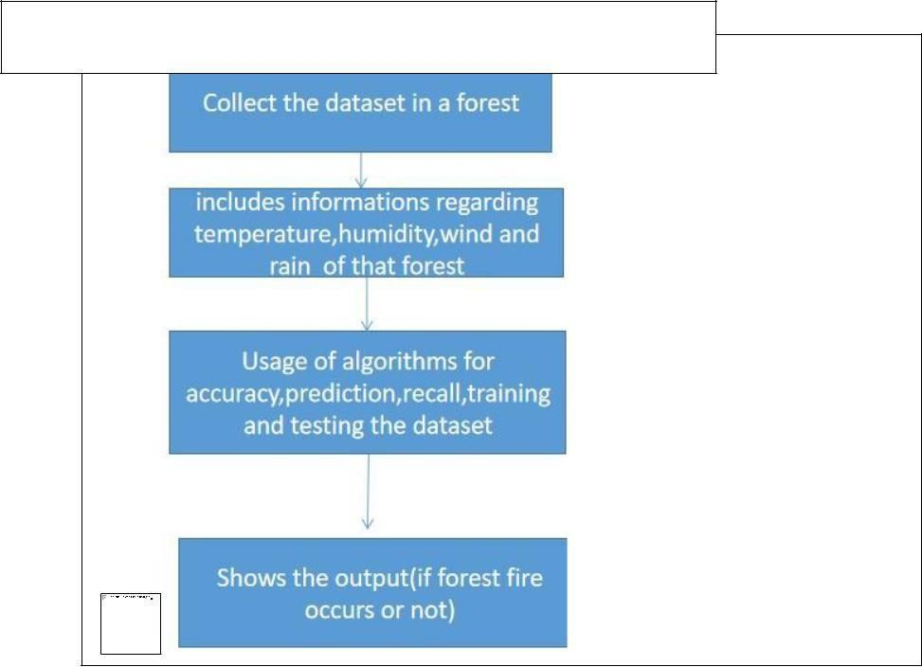

DFD Level (Industry Standard)

1. EVALUATE DATA SET
2. IMPLEMENT ALGORITHMS
3. EVALUATE THE ACCURACY OF EACH ALGORITHMS
4. DISPLAY RESULTS

# User Stories

Use the below template to list all the user stories for the product.

|  |  |  |  |  |  |  |
| --- | --- | --- | --- | --- | --- | --- |
| **User Type** | **Functional** | **User Story** | **User Story / Task** | **Acceptance criteria** | **Priority** | **Release** |
| **Requirement (Epic)** | **Number** |
| Environmentalist | Collect the data | USN-1 | As an Environmentalist,it is necessary to | It is necessary to collect | High | Sprint-1 |
| collect the data of the forest which includes | the right data else the |
| temperature,humidity,wind and rain of the | prediction may become |
| forest | wrong |
|  |  | USN-2 | Identify algorithms that can be used for | To collect the algorithm to | Medium | Sprint-2 |
| prediction | identify the accuracy level of each algorithms |
|  |  | USN-3 | Identify the accuracy of each algorithms | Accuracy of each algorithm-calculated so that it is easy to obtain the most accurate output | High | Sprint-2 |
|  |  | USN-4 | Evaluate the Dataset | Data is evaluated before processing | Medium | Sprint-1 |
|  |  | USN-5 | Identify accuracy,precision,recall of each | These values are | High | Sprint-3 |
| algorithms | important for obtaining the right output |
|  |  | USN-6 | Outputs from each algorithm are obtained | It is highly used to predict the effect and to take precautionary measures. | High | Sprint-4 |